QUESTIONNAIRE FOR the
STRUCTURE DETERMINATION BY POWDER DIFFRACTOMETRY ROUND ROBIN - 3

d
Please answer all questions as completely as possible. Provide
one filled questionnaire for each data (samples 1 and 2).

Preferably, attach the results as one PDF file or as a MS Word
document compressed by Winzip.

It is advised to complete the form as the structure determination
progress.

O.0 Precise date of
- data download : Fri, 1 Feb 2008 afternoon
- results submission : Fri, 8 Feb 2008

0.1 Is the first sample structure solvable with this quality
of data ? Yes [*] No [ ]
0.2 Is the second sample structure solvable with this quality
of data ? Yes [*] No [ ]
0.3 If not, what data would be required ?

Then, for each sample :

1. Preliminary work

1.1 Did you obtained additional informations ? No.
(for instance from CSD or ICSD or ICDD databases)

1.2 Did you obtained additional informations from the
powder pattern ? If yes, how and what information ? No.
(for instance using the JCPDS-ICDD database)

1.3 Did you extract the structure factors ? Yes [*] No [ ]

I extracted intensities using the Le Bail method with GSAS and used for input to Shelxs or Sir2002. Later on, I tried to perform whole pattern decomposition with EXPO, also without much success.

1.3.1 If yes, which program(s) did you use ?
1.3.2 Give the angular range: 8-50 in 2theta
1.3.3 Give the number of extracted structure factors: 180
1.3.4 Give the Rp and Rwp (conventional Rietveld, background subtracted): 0,0649 and 0,0658 with Manually determined background points
1.3.5 Give the Rp and Rwp (background not
subtracted): 0,0279 and 0,0383

1.3.6 If not, did you use the whole pattern ?
1.3.7 Or a partial pattern (if yes, give the angular range):
1.3.8 If you use the whole or a partial pattern, did you keep fixed the
profile parameters, and if yes, how did you obtained them ?

2- Structure solution

2.1 Did you use direct methods ? Yes [*] No [ ]

2.1.1 If yes, was it on the whole dataset ? On the extracted reflections
2.1.2 Or on a partial dataset ?
2.1.3 Give the number of reflections: 180
2.1.4 Which program(s) did you use ? Shelxs, Sir2002
2.1.5 Did you modified intensities of closely neighbouring
reflections ? If yes, explain how. No.

2.2 Did you use Patterson methods ? Yes [*] No [ ]

2.2.1 If yes, was it on the whole dataset ? On the same set of extracted intensities.
2.2.2 Or on a partial dataset ?
2.2.3 Give the number of reflections: 180
2.2.4 Which program(s) did you use ? Shelxs
2.2.5 Did you modified intensities of closely neighbouring
reflections ? If yes, explain how. No.

2.3 Did you use another method ? Yes [*] No [ ]

2.3.1 If yes, which method(s) (give details : molecule location
by direct space - genetic algorithm, Monte Carlo, Simulated
annealing, scratch, charge flipping, other) ?
Paralell tempering

2.3.2 Which program(s) did you use (name and reference) ?
Fox, version 1.7.1.1 Dec 4 2007

2.3.3 If you used direct space methods, how many independent
molecules did you use (give details on these molecules)? How
many degrees of freedom (total) ? How many torsion angles ?

A few different attempts. (1) tartarate treated as a molecule, calcium and four oxygen atoms all treated independently of each other; dof: 24 torsions 3 . (2) only with two or three oxygen atoms bonded to calcium atom; dof: 18, torsions 3 (3) as 1 with more than four not bonded oxygen atoms dof: around 30, torsions 3.

2.4 Did you first locate the whole structure ? Yes [*] No [ ]

2.4.1 If not, how many atoms did you locate ?
2.4.2 Give their name and initial atomic coordinates
Atom x y z

C1 0.5050 0.3701 0.8419
C2 0.3201 0.3840 0.7142
C3 0.0878 0.3767 0.7444
C4 -0.1148 0.3542 0.6100
O5 -0.2115 0.2242 0.5179
O6 -0.1985 0.4861 0.5947
O7 0.4499 0.2166 0.8786
O8 0.7007 0.4790 0.9012
O9 0.4197 0.5381 0.6720
O10 0.1210 0.5314 0.8256
H11 0.2846 0.2732 0.6370
H12 0.0252 0.2653 0.7966_________atoms above: tartarate
Ca1 0.1592 0.3120 0.2280
O1 0.8055 0.1218 0.2725
O2 0.6237 0.8175 0.8893
O3 0.1132 0.8025 0.0111
O4 0.3191 0.1516 0.3977

2.4.3 Were the initial atomic coordinates taken from a known
structure ? Not to me at least. Yes [ ] No [*]
If yes, which one (give reference) ?

3- Structure completion

3.1 Did you performed Fourier difference syntheses before
refining the structure by the Rietveld method ? Yes [ ] No [*]
3.2 If yes, with what program ?
3.3 If yes, how many additional atoms did you obtained from Fourier
difference syntheses ?
3.4 Give their name and atomic coordinates as they were obtained
Atom x y z
.................................
.................................
.................................

3.5 Did you made first Rietveld refinements without preliminary
Fourier difference syntheses ? Yes [*] No [ ]
3.5.1 If yes, with what program ? GSAS
3.5.2 What were the Rp and Rwp (background subtracted AND not
subtracted) and RB and RF that you obtained at the first
Rietveld application ?
Haven’t written it down. As I recall Rwp~0,11; Rwp(-bknd)~0,15

3.5.3 Did you get the structure factors from this result and
performed a Fourier difference synthesis ? No.
3.5.4 Did you locate additional atoms at this stage ? No.
3.5.5 And which one ?
Atom x y z
.................................
.................................
.................................

3.5.6 If you repeated Rietveld refinements and Fourier synthese
several times before to complete the model, give the number
of times and which atoms you locate and the Rp, Rwp
RB, RF at each times.
Atom x y z
.................................
.................................
.................................

4- Final refinement

- Give the final atomic coordinates, thermal parameters,
standard deviations, Reliability factors...........
Atom x y z B

C1 0.4969(21) 0.3622(16) 0.8337(14) 1.0 0.0498(9)
C2 0.3004(28) 0.3898(16) 0.7160(13) 1.0 0.0498(9)
C3 0.0801(26) 0.3716(18) 0.7534(13) 1.0 0.0498(9)
C4 -0.0971(25) 0.3551(15) 0.6281(15) 1.0 0.0498(9)
O5 -0.2034(13) 0.2052(11) 0.5360(9) 1.0 0.0498(9)
O6 -0.1787(15) 0.4757(11) 0.5900(8) 1.0 0.0498(9)
O7 0.4271(14) 0.2031(12) 0.8697(8) 1.0 0.0498(9)
O8 0.6845(15) 0.4753(10) 0.9007(8) 1.0 0.0498(9)
O9 0.4214(15) 0.5354(11) 0.6732(8) 1.0 0.0498(9)
O10 0.1388(15) 0.5293(11) 0.8434(9) 1.0 0.0498(9)
H11 0.265(11) 0.277(7) 0.623(6) 1.0 0.0498(9)
H12 0.095(13) 0.255(7) 0.798(7) 1.0 0.0498(9)
CA13 0.1630(5) 0.3127(4) 0.22960(31) 1.0 0.0498(9)
O14 0.8067(13) 0.1226(9) 0.2715(8) 1.0 0.0498(9)
O15 0.6339(12) 0.8471(10) 0.8812(7) 1.0 0.0498(9)
O16 0.1216(14) 0.8148(10) 0.0100(9) 1.0 0.0498(9)
O17 0.3194(11) 0.1478(9) 0.3969(7) 1.0 0.0498(9)

- Give details about constraints, restraints

I used restraints on bond lengths and angles.

5- Feel free to add any intermediate results (list of extracted structure
factors, software decisive input and output data...) or comments you
might consider as essential (details on hardware, time for solving the
structure, number of moves by Monte Carlo or molecule position trial,
any picture...).

I strongly believe that this is the correct structure. I had a few doubts as it is stated on the website that this is a polymorph of enantiomerically pure calcium tartarate. This structure I got to is a racemate. I have tried to find initial model using all of the above named methods in P1 space group but with no meaningful results. And I would be very surprised to find that I could get a Rietveld fit this good and chemically very sensible structure with a wrong structure. Additionally, this structure model didn’t show a hint of divergence in least squares.

I hope I’ve answered all questions. I will be happy to answer if I left something that needs clarification.

With kind regards,

Ivan Halasz
Department of Chemistry
Faculty of Science
University of Zagreb
Horvatovac 102a
10000 Zagreb, Croatia
Tel. +385 1 4606 416

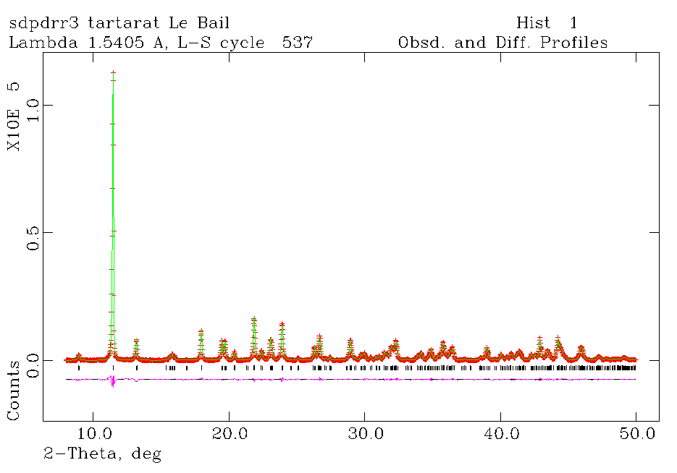
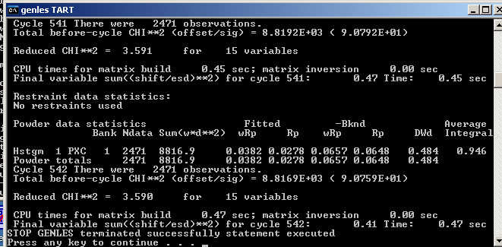
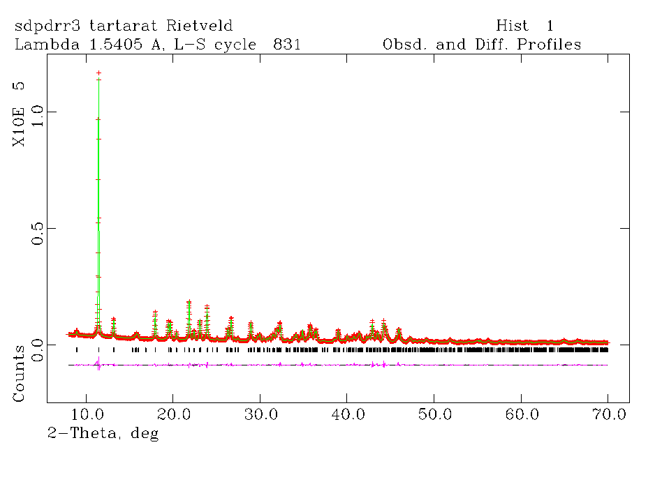

data_TART_publ

_pd_block_id
2008-02-08T12:31|TART|Ivan_Halasz|Overall

_audit_creation_method "from EXP file using GSAS2CIF"
_audit_creation_date 2008-02-08T12:31
_audit_author_name "Ivan Halasz"
_audit_update_record
; 2008-02-08T12:31 Initial CIF as created by GSAS2CIF
;

#=============================================================================
# this information describes the project, paper etc. for the CIF #
# Acta Cryst. Section C papers and editorial correspondence is generated #
# from the information in this section #
# #
# (from) CIF submission form for Rietveld refinements (Acta Cryst. C) #
# Version 14 December 1998 #
#=============================================================================
# 1. SUBMISSION DETAILS

_publ_contact_author_name ? # Name of author for correspondence
_publ_contact_author_address # Address of author for correspondence
; ?
;
_publ_contact_author_email ?
_publ_contact_author_fax ?
_publ_contact_author_phone ?

_publ_contact_letter
; ?
;

_publ_requested_journal ?
_publ_requested_coeditor_name ?
_publ_requested_category ? # Acta C: one of CI/CM/CO/FI/FM/FO

#==============================================================================

# 2. PROCESSING SUMMARY (IUCr Office Use Only)

_journal_data_validation_number ?

_journal_date_recd_electronic ?
_journal_date_to_coeditor ?
_journal_date_from_coeditor ?
_journal_date_accepted ?
_journal_date_printers_first ?
_journal_date_printers_final ?
_journal_date_proofs_out ?
_journal_date_proofs_in ?
_journal_coeditor_name ?
_journal_coeditor_code ?
_journal_coeditor_notes
; ?
;
_journal_techeditor_code ?
_journal_techeditor_notes
; ?
;
_journal_coden_ASTM ?
_journal_name_full ?
_journal_year ?
_journal_volume ?
_journal_issue ?
_journal_page_first ?
_journal_page_last ?
_journal_paper_category ?
_journal_suppl_publ_number ?
_journal_suppl_publ_pages ?

#==============================================================================

# 3. TITLE AND AUTHOR LIST

_publ_section_title
; ?
;
_publ_section_title_footnote
; ?
;

# The loop structure below should contain the names and addresses of all
# authors, in the required order of publication. Repeat as necessary.

loop_
_publ_author_name
_publ_author_footnote
_publ_author_address
? #<--'Last name, first name'
; ?
;
; ?
;

#==============================================================================

# 4. TEXT

_publ_section_synopsis
; ?
;
_publ_section_abstract
; ?
;
_publ_section_comment
; ?
;
_publ_section_exptl_prep # Details of the preparation of the sample(s)
# should be given here.
; ?
;
_publ_section_exptl_refinement
; ?
;
_publ_section_references
; ?
;
_publ_section_figure_captions
; ?
;
_publ_section_acknowledgements
; ?
;

#=============================================================================
# 5. OVERALL REFINEMENT & COMPUTING DETAILS

_refine_special_details
; ?
;
_pd_proc_ls_special_details
; ?
;

# The following items are used to identify the programs used.
_computing_molecular_graphics ?
_computing_publication_material ?

_refine_ls_weighting_scheme ?
_refine_ls_weighting_details ?
_refine_ls_hydrogen_treatment ?
_refine_ls_extinction_method ?
_refine_ls_extinction_coef ?
_refine_ls_number_constraints ?

_refine_ls_restrained_S_all ?
_refine_ls_restrained_S_obs ?

#==============================================================================
# 6. SAMPLE PREPARATION DATA

# (In the unusual case where multiple samples are used in a single
# Rietveld study, this information should be moved into the phase
# blocks)

# The following three fields describe the preparation of the material.
# The cooling rate is in K/min. The pressure at which the sample was
# prepared is in kPa. The temperature of preparation is in K.

_pd_prep_cool_rate ?
_pd_prep_pressure ?
_pd_prep_temperature ?

_pd_char_colour ? # use ICDD colour descriptions
data_TART_overall

_refine_ls_shift/su_max 0.00
_refine_ls_shift/su_mean 0.00
_computing_structure_refinement GSAS
_refine_ls_number_parameters 1
_refine_ls_goodness_of_fit_all 5.30
_refine_ls_number_restraints 35
_refine_ls_matrix_type full

# pointers to the phase blocks
loop_ _pd_phase_block_id
2008-02-08T12:31|TART_phase1|Ivan_Halasz||
# pointers to the diffraction patterns
loop_ _pd_block_diffractogram_id
?

# Information for phase 1
data_TART_phase_1

_pd_block_id
2008-02-08T12:31|TART_phase1|Ivan_Halasz||

#==============================================================================
# 7. CHEMICAL, STRUCTURAL AND CRYSTAL DATA

_pd_char_particle_morphology ?

_chemical_name_systematic
; ?
;
_chemical_name_common ?
_chemical_formula_moiety ?
_chemical_formula_structural ?
_chemical_formula_analytical ?
_chemical_melting_point ?
_chemical_compound_source ? # for minerals and
# natural products
_symmetry_space_group_name_Hall ?

_exptl_crystal_F_000 ?
_exptl_crystal_density_diffrn ?
_exptl_crystal_density_meas ?
_exptl_crystal_density_method ?

_cell_measurement_temperature ?

_cell_special_details
; ?
;

_geom_special_details ?

# The following item identifies the program(s) used (if appropriate).
_computing_structure_solution ?

#==============================================================================

# 8. Phase information from GSAS

_pd_phase_name tart
_cell_length_a 6.25092(15)
_cell_length_b 8.22598(23)
_cell_length_c 10.43844(20)
_cell_angle_alpha 94.9368(15)
_cell_angle_beta 105.9512(16)
_cell_angle_gamma 107.5183(17)
_cell_volume 483.732(20)
_symmetry_cell_setting triclinic
_symmetry_space_group_name_H-M "P -1"
loop_ _symmetry_equiv_pos_site_id _symmetry_equiv_pos_as_xyz
1 +x,+y,+z
-1 -x,-y,-z

# ATOMIC COORDINATES AND DISPLACEMENT PARAMETERS

loop_
_atom_site_type_symbol
_atom_site_label
_atom_site_fract_x
_atom_site_fract_y
_atom_site_fract_z
_atom_site_occupancy
_atom_site_thermal_displace_type
_atom_site_U_iso_or_equiv
_atom_site_symmetry_multiplicity
C
C1 0.505 0.3701 0.8419 1.0 Uiso 0.025 2
C
C2 0.3201 0.384 0.7142 1.0 Uiso 0.025 2
C
C3 0.0878 0.3767 0.7444 1.0 Uiso 0.025 2
C
C4 -0.1148 0.3542 0.61 1.0 Uiso 0.025 2
O
O5 -0.2115 0.2242 0.5179 1.0 Uiso 0.025 2
O
O6 -0.1985 0.4861 0.5947 1.0 Uiso 0.025 2
O
O7 0.4499 0.2166 0.8786 1.0 Uiso 0.025 2
O
O8 0.7007 0.479 0.9012 1.0 Uiso 0.025 2
O
O9 0.4197 0.5381 0.672 1.0 Uiso 0.025 2
O
O10 0.121 0.5314 0.8256 1.0 Uiso 0.025 2
H
H11 0.2846 0.2732 0.637 1.0 Uiso 0.025 2
H
H12 0.0252 0.2653 0.7966 1.0 Uiso 0.025 2
Ca
CA13 0.1592 0.312 0.228 1.0 Uiso 0.025 2
O
O14 0.8055 0.1218 0.2725 1.0 Uiso 0.025 2
O
O15 0.6237 0.8175 0.8893 1.0 Uiso 0.025 2
O
O16 0.1132 0.8025 0.0111 1.0 Uiso 0.025 2
O
O17 0.3191 0.1516 0.3977 1.0 Uiso 0.025 2

loop_ _atom_type_symbol
_atom_type_number_in_cell
C 8.0
O 20.0
H 4.0
Ca 2.0

# If you change Z, be sure to change all 3 of the following
_chemical_formula_sum "C4 H2 Ca O10"
_chemical_formula_weight 250.13
_cell_formula_units_Z 2

# MOLECULAR GEOMETRY

loop_
_geom_bond_atom_site_label_1
_geom_bond_atom_site_label_2
_geom_bond_distance
_geom_bond_site_symmetry_1
_geom_bond_site_symmetry_2
_geom_bond_publ_flag
C1 C2 1.54427(4) . 1_555 N
C1 O7 1.324280(30) . 1_555 N
C1 O8 1.22913(4) . 1_555 N
C1 CA13 3.10524(8) . -1_666 N
C2 C1 1.54427(4) . 1_555 N
C2 C3 1.55368(4) . 1_555 N
C2 O9 1.400090(30) . 1_555 N
C2 H11 1.087610(30) . 1_555 N
C3 C2 1.55368(4) . 1_555 N
C3 C4 1.56332(4) . 1_555 N
C3 O10 1.39269(4) . 1_555 N
C3 H12 1.130050(30) . 1_555 N
C4 C3 1.56332(4) . 1_555 N
C4 O5 1.24407(4) . 1_555 N
C4 O6 1.342440(30) . 1_555 N
C4 CA13 3.22394(8) . -1_566 N
O5 C4 1.24407(4) . 1_555 N
O6 C4 1.342440(30) . 1_555 N
O6 CA13 2.28459(5) . -1_566 N
O7 C1 1.324280(30) . 1_555 N
O8 C1 1.22913(4) . 1_555 N
O8 CA13 2.38398(5) . -1_666 N
O9 C2 1.400090(30) . 1_555 N
O9 H11 2.04463(6) . 1_555 N
O9 CA13 2.41932(7) . -1_666 N
O10 C3 1.39269(4) . 1_555 N
O10 H12 2.05885(6) . 1_555 N
O10 CA13 2.44622(5) . -1_566 N
H11 C2 1.087610(30) . 1_555 N
H11 O9 2.04463(6) . 1_555 N
H12 C3 1.130050(30) . 1_555 N
H12 O10 2.05885(6) . 1_555 N
CA13 C1 3.10524(8) . -1_666 N
CA13 C4 3.22394(8) . -1_566 N
CA13 O6 2.28459(5) . -1_566 N
CA13 O8 2.38398(5) . -1_666 N
CA13 O9 2.41932(7) . -1_666 N
CA13 O10 2.44622(5) . -1_566 N
CA13 O14 2.48174(6) . 1_455 N
CA13 O15 2.45658(5) . -1_666 N
CA13 O16 2.51192(7) . -1_565 N
CA13 O17 2.47000(5) . 1_555 N
O14 CA13 2.48174(6) . 1_655 N
O15 CA13 2.45658(5) . -1_666 N
O16 CA13 2.51192(7) . -1_565 N
O17 CA13 2.47000(5) . 1_555 N

loop_
_geom_angle_atom_site_label_1
_geom_angle_atom_site_label_2
_geom_angle_atom_site_label_3
_geom_angle
_geom_angle_site_symmetry_1
_geom_angle_site_symmetry_2
_geom_angle_site_symmetry_3
_geom_angle_publ_flag
C2 C1 O7 114.1749(20) 1_555 . 1_555 N
C2 C1 O8 126.3713(18) 1_555 . 1_555 N
O7 C1 O8 119.0339(17) 1_555 . 1_555 N
C1 C2 C3 110.4558(17) 1_555 . 1_555 N
C1 C2 O9 108.0528(20) 1_555 . 1_555 N
C1 C2 H11 106.7168(20) 1_555 . 1_555 N
C3 C2 O9 112.1487(16) 1_555 . 1_555 N
C3 C2 H11 109.3994(19) 1_555 . 1_555 N
O9 C2 H11 109.9149(19) 1_555 . 1_555 N
C2 C3 C4 110.5267(18) 1_555 . 1_555 N
C2 C3 O10 109.9851(18) 1_555 . 1_555 N
C2 C3 H12 112.3067(15) 1_555 . 1_555 N
C4 C3 O10 107.3331(20) 1_555 . 1_555 N
C4 C3 H12 107.5796(20) 1_555 . 1_555 N
O10 C3 H12 108.9514(19) 1_555 . 1_555 N
C3 C4 O5 126.5707(17) 1_555 . 1_555 N
C3 C4 O6 116.6538(17) 1_555 . 1_555 N
O5 C4 O6 116.7299(18) 1_555 . 1_555 N
C4 O6 CA13 123.3521(15) 1_555 . -1_566 N
C1 O8 CA13 114.6948(18) 1_555 . -1_666 N
C2 O9 CA13 117.7954(17) 1_555 . -1_666 N
C3 O10 CA13 121.8789(18) 1_555 . -1_566 N
O6 CA13 O8 94.4849(20) -1_566 . -1_666 N
O6 CA13 O9 74.6355(21) -1_566 . -1_666 N
O6 CA13 O10 66.1752(17) -1_566 . -1_566 N
O6 CA13 O14 87.8266(21) -1_566 . 1_455 N
O6 CA13 O15 144.4202(11) -1_566 . -1_666 N
O6 CA13 O16 136.1651(13) -1_566 . -1_565 N
O6 CA13 O17 87.3647(19) -1_566 . 1_555 N
O8 CA13 O9 69.2527(17) -1_666 . -1_666 N
O8 CA13 O10 72.8463(17) -1_666 . -1_566 N
O8 CA13 O14 145.5281(10) -1_666 . 1_455 N
O8 CA13 O15 75.7452(18) -1_666 . -1_666 N
O8 CA13 O16 74.3590(20) -1_666 . -1_565 N
O8 CA13 O17 138.6830(13) -1_666 . 1_555 N
O9 CA13 O10 121.8813(19) -1_666 . -1_566 N
O9 CA13 O14 143.3066(12) -1_666 . 1_455 N
O9 CA13 O15 69.8952(20) -1_666 . -1_666 N
O9 CA13 O16 134.0727(15) -1_666 . -1_565 N
O9 CA13 O17 71.5624(19) -1_666 . 1_555 N
O10 CA13 O14 76.7993(20) -1_566 . 1_455 N
O10 CA13 O15 137.7502(11) -1_566 . -1_666 N
O10 CA13 O16 70.0426(17) -1_566 . -1_565 N
O10 CA13 O17 142.2617(9) -1_566 . 1_555 N
O14 CA13 O15 119.6049(19) 1_455 . -1_666 N
O14 CA13 O16 80.2779(21) 1_455 . -1_565 N
O14 CA13 O17 75.7401(19) 1_455 . 1_555 N
O15 CA13 O16 74.8075(18) -1_666 . -1_565 N
O15 CA13 O17 79.0598(16) -1_666 . 1_555 N
O16 CA13 O17 128.9280(16) -1_565 . 1_555 N
#--eof--eof--eof--eof--eof--eof--eof--eof--eof--eof--eof--eof--eof--eof--eof--#

