THE RIETVELD METHOD

by Hugo M. Rietveld

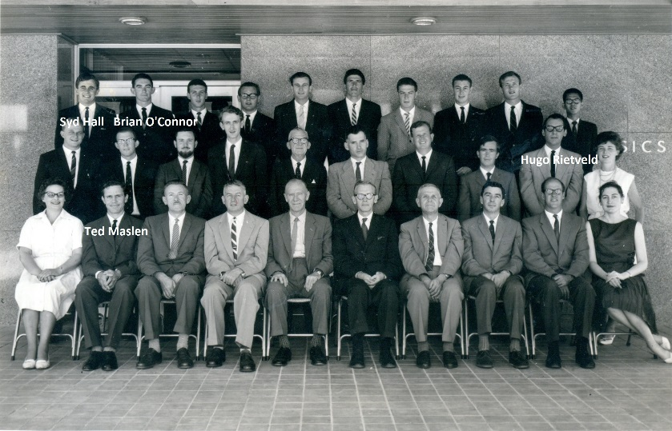
In 1957 I enrolled at the University of Western Australia as a physics student together with Brian O’Connor and Syd Hall, both of whom became well known crystallographers. I did my Ph.D. study under the supervision of Ted Maslen who had come from Oxford where he studied under Dorothy Hodgkin.
Staff and Ph.D. Students 1962
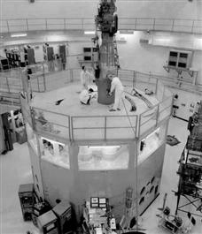
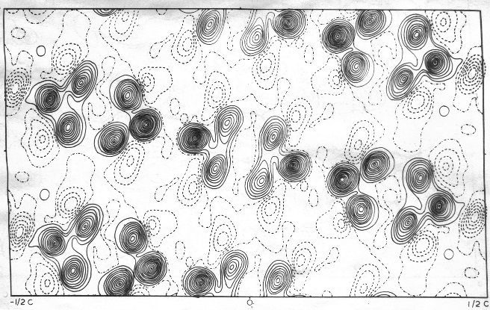
In 1960 Ted Maslen and I undertook the first single crystal neutron diffraction study in Australia on the compound p-diphenyl benzene. Automation, particularly by means of a computer, was hardly known. At the Atomic Research Establishment in Lucas Heights, we had to set the crystal orientation on the goniometerhead by hand. The only automatic process was the theta-2theta scan, producing in one hour, a piece of paper with approximately forty intensities per reflection. Because of this, our continual attendance was required and we often worked twelve hours shifts. This was hard work. I hoped that the rest of my scientific career would consist of more intellectual activities! Nevertheless all of this was forgotten when, for the first time, on a hand plotted Fourier map, we saw the peaks of the hydrogen atoms next to the carbon atoms. A moment to be remembered! (Clews, Maslen,Rietveld,Sabine,1961) It may well be that these early experiences led me to vigorously embrace the possibilities of automation created by the introduction of computers. They also convinced me at that time that decent crystallographic work could only be done by means of single crystal diffraction. A Guinier film of the same compound may have consisted of numerous lines, often overlapping, and could only be used to determine the spacegroup and the unit-cell dimensions.
HIFAR Reactor in Lucas Heights
Fourier Map of p-diphenyl benzene
At that time the Physics Department installed the first electronic computer, the IBM 1620. Programming was done in Fortran II, with punched cards for in- and output. Compared to today’s standards this computer was thousand times smaller and slower than any home computer! Nevertheless we learned to appreciate the calculating power of this new computer.

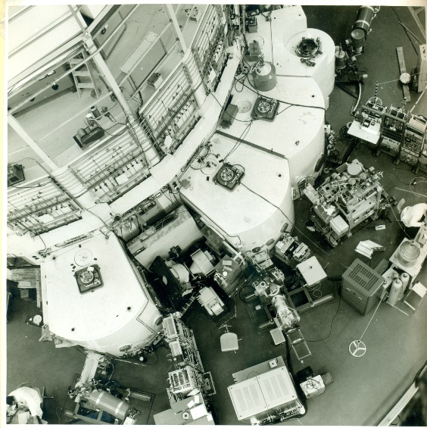
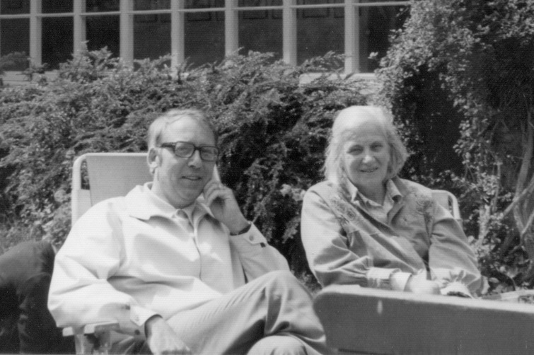
After obtaining my Ph.D. degree in 1964 (Rietveld,1963) with Dorothy Hodgkin as my examiner, (who at that time received the Nobel Prize for her study on penicillin), I joined the neutron diffraction group of the Reactor Centrum Nederland (now Netherlands Energy Research Foundation ECN) in The Netherlands. This group had only just been established and was principally engaged in the construction of a neutron powder diffractometer. The emphasis here was mainly on powder diffraction techniques, because it was apparent that no large, single crystals could be grown of the materials that were then of interest. The first crystal structures to be determined were rather simple and of a high symmetry, with the result that the peaks were well resolved and could easily be obtained for further refinement. However, with compounds more complex and of lower symmetry, the overlap of peaks became so severe that separating them became practically impossible. In an effort to overcome this problem, the resolution of the diffractometer was significantly increased by using a wavelength of 2.6 Å and by eliminating the higher order wavelength with a filter of pyrolytic graphite.
This proved to be of appreciable value, especially for structure determination. For structure refinement, however, the increase of resolution certainly resulted in a better defined pattern, but often not to such an extent that the peaks were completely resolved. The solution then was to refine the structure by using not only single Bragg reflection intensities as data, but also groups of overlapping intensities (Rietveld, 1966). This worked well, but the fact remained that all extra information contained in the profile of these over-lapping peaks was lost. The following step was to separate the overlapping peaks by trying to fit Gaussian peaks using least squares procedures. This method also had its limitations, however, and did not work for severe overlap.
HFR Reactor at Petten
With Dorothy Hodgkin at her cottage.

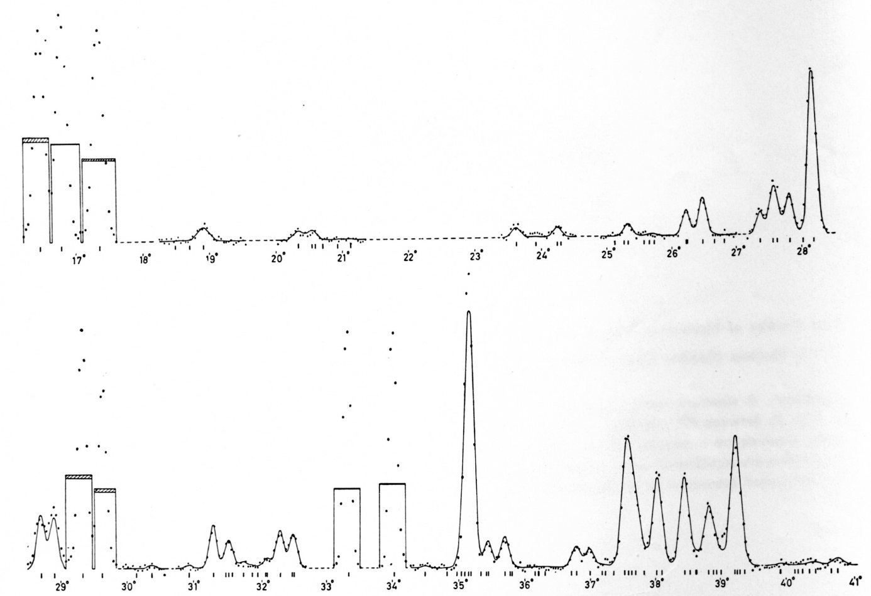
Before the advent of computers, data reduction was a must in crystallography in order to be able to handle a relatively complex structure. Integrated intensities were therefore the smallest data elements one could work with practically. To consider using the individual intensities, $y\left(i\right),$ constituting a step-canned diffraction diagram as data, was completely unrealistic. With my experience of using computers for single crystal structure refinements and having seen their enormous capacity for handling large amounts of data, I saw the spectre of increasing the number of data by a factor of ten by using the individual intensities $y^{i}$, instead of the integrated intensities, constituted no reaI barrier. In the first refinement program, the intensities${ y}^{i}$ were corrected for background and were read in together with the value of the relative contributions each constituent peak made, i.e. the value of $ω_{i}^{k}$ in the expression $y_{obs}^{i}= c^{᾿} \sum_{k}{ω_{i}^{k}} F_{k}^{2}+ b_{i}$ (Rietveld 1967), where $F_{k}$ is the structure factor and $b_{i}$ the background. These values were calculated from the unit-
Neutron powder diagram of WO(3)

cell dimensions and the wavelength, and zeropoint and halfwidth values measured directly from the diagram. Also, for resolved peaks the integrated values were used rather than the${ y}^{i }$intensities, because the Gaussian peak shape did not fit well at lower angles. Later, a correction for this asymmetry was introduced. The non-refinement of the reflection-profile parameters can be explained by the fact that the then available computer, the Electrologica X1, was not powerful enough to solve a least squares problem of more than a very limited number of parameters. With the arrival of the larger Electrologica X8 computer, the program was rewritten to include the capability of refining structure as well as profile parameters (Rietveld 1969). Twenty-seven copies of this program, written in Algol and later, in 1972, in FORTRAN IV, were distributed to institutes all over the world.
The method was first reported at the Seventh Congress of IUCr in Moscow in 1966 . The response was slight, or, rather, non-existent, and it was not until the full implementation of the method was published (Rietveld 1969), that reactions came. At this time, the method was mainly used to refine structures from data obtained by fixed wavelength neutron diffraction; a total of 172 structures were refined in this way before 1977. In the previously mentioned paper (Rietveld 1969), it had been suggested that the method could also be applied to X-ray data, but it was not until 1977 that the method became generally accepted for X-ray as weIl as neutron powder diffraction, first with fixed wavelength and then also with fixed angle (energy dispersive data). This is reflected in an increasing number of citations to the original papers (Rietveld 1967 and 1969) as shown in Google Scholar.
Number of publications per year citing the Rietveld Method according to Google Scholar

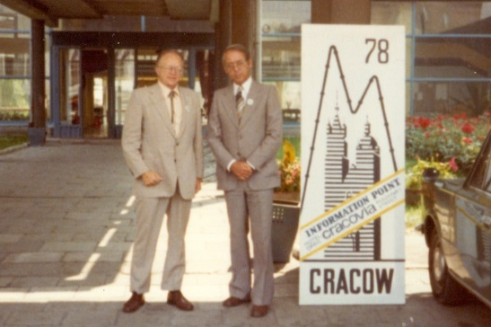
While I named my method originally Profile Refinement Method, many authors used different names in the literature. In order to prevent further confusion, during the Neutron conference in Cracow, Terry Sabine and Ray Young proposed to name the method, Rietveld Method, and this was then accepted by the Commission on Neutron Diffraction.
With Ray Young

In June 1989 the IUCr Commission on Powder Diffraction in co-operation with the Netherlands Energy Research Centre (ECN) organized a workshop on the Rietveld Method in Petten, The Netherlands. This resulted in the Publication of the IUCr Monograph “The Rietveld Method” edited by R.A. Young (ISBN 0-19-855912-7).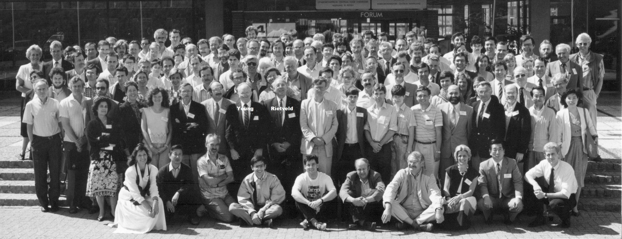
International Workshop on the Rietveld Method, 1989

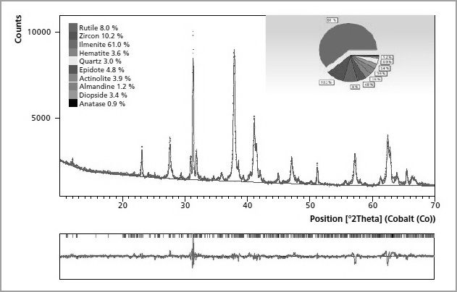
An unexpected application of the method was to Quantitative Phase Analysis. This resulted in an increased use in industry and also to the marketing of commercial software by firms such as Panalytical, Bruker and Rikagu.
Rietveld Quantitative Phase Analysis Diagram

Number of publications per year citing the Rietveld Quantitative Phase Analysis according to Google Scholar.

To see how the method has developed is to me most gratifying and I am grateful to have been able to contribute to the importance of the field of crystallography.

For my method I received the following awards:

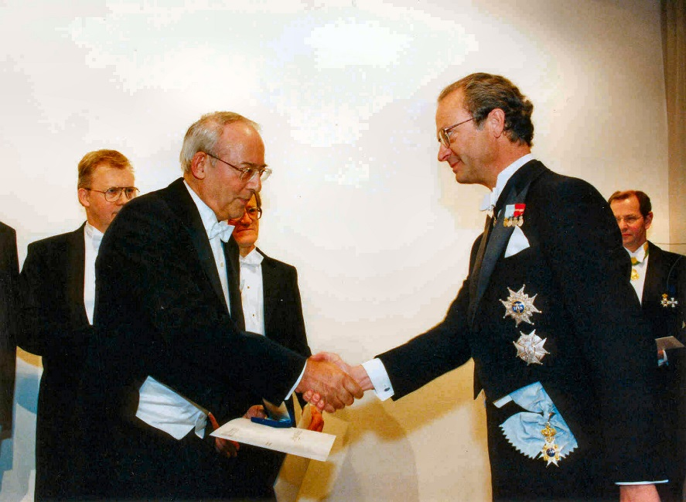
. .Aminoff Prize by the Royal Academy of Sciences (1995.
King Gustav of Sweden presents the Aminoff Prize 1995

.Barrett Award by the Denver X-ray Conference (2003)

. Award for Distinguished Powder Diffractionist by the European
Powder Diffraction Conference (2010)

. Hans-Kühl- Medaille by Die Gesellschaft Deutscher Chemiker (2010)

References
Clews,C.J.B., Maslen,E.N., Rietveld,H.M. & Sabine,T.M. (1961).Nature,192,154.

Rietveld,H.M.(1963). Ph. D. Thesis, Univ. of Western Australia

Rietveld,H.M.(1966), Acta Cryst. 20, 508.

Rietveld,H.M.(1967), Acta Cryst. 22, 151.

Rietveld, H.M.(1969), J. Appl. Cryst. 2, 65.

